Chicken and Spinach Pasta Bake

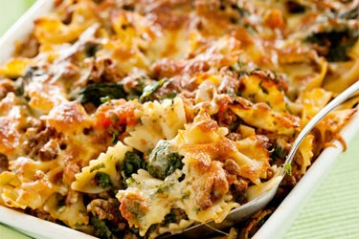
Ingredients
1 pack Penne pasta
1 teaspoon olive oil
1 onion
1 pack quorn chicken style pieces
1 tin Italian style chopped tomatoes
1 pack spinach
1 pack cream cheese
1 ball of mozzarella, cut into small pieces

Method
- Preheat oven to 375 degrees F (190 degrees C).
- Bring a large pot of lightly salted water to a boil; add penne and cook, stirring occasionally, until tender yet firm to the bite, about 11 minutes. Drain.
- Heat olive oil in a frying pan over medium-high heat. Fry the onion in hot oil until tender, 5 to 7 minutes. Add the quorn pieces and fry for a further 5 minutes until heated through.
- Mix penne pasta, onion, chicken, diced tomatoes, spinach, and cream cheese together in a baking dish until the cream cheese melts and coats everything. Sprinkle mozzarella cheese over the pasta mixture. Cover baking dish with aluminum foil.
- Bake in the preheated oven for 30 minutes. Remove foil and continue baking until heated through and beginning to brown along the edges, about 15 minutes more.

Double Chocolate Chip Cookies
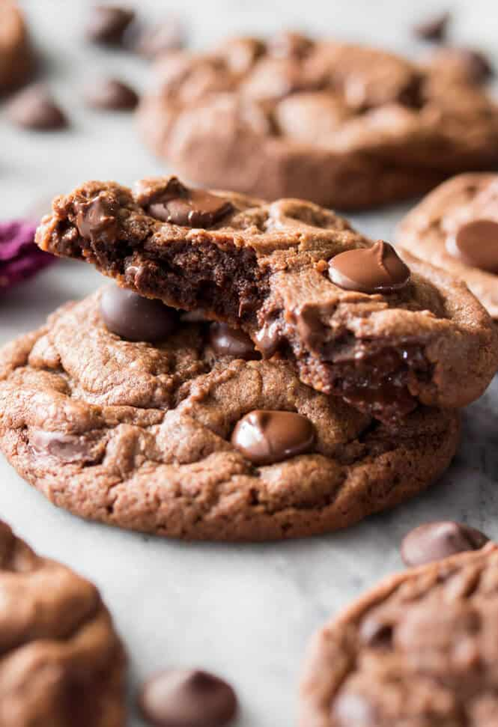
Ingredients
200g softened butter
300g soft brown sugar
2 tsp vanilla extract
2 eggs
300g self-raising flour
80g cocoa powder
1 tsp baking powder
300g choc chips

Method
- Preheat oven to 180 c/ gas 4
- Cream butter and sugar until light and fluffy, then beat in vanilla extract and eggs
- In a separate bowl sift flour, cocoa and baking powder together
- Add flour mix to the creamed mix in stages( a third at a time) mix well. Fold in choc chips until just combined.
- Spoon a tablespoon of the mixture on to a baking tray and just let it drop off the spoon, repeat until you have used up all the cookie mixture.
- Bake in preheated oven for 12 minutes, when you remove the cookies from the oven they will still be soft, leave to cool completely on the baking tray, where they will continue to cook slightly, when completely cold move to a cooling rack. Then enjoy.

