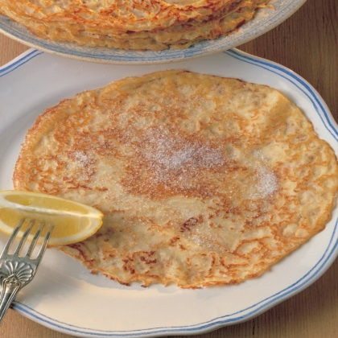
PANCAKES

INGREDIENTS

110g plain flour
pinch of salt
2 large eggs
200ml semi-skimmed milk mixed with 75ml water
50g butter

METHOD

- Sift the flour and salt into a large mixing bowl with the sieve held high above the bowl.
- Make a well in the centre of the flour and break the eggs into it. Then begin whisking the eggs. When the mixture starts thicken, gradually add small quantities of the milk and water mixture, still whisking (don't worry about any lumps as they will eventually disappear as you whisk).
- When all the liquid has been added, use a rubber spatula to scrape the bits of flour from around the edge into the centre, then whisk once more until the batter is smooth, with the consistency of thin cream.
- Now melt the butter in the pan. Spoon 2 tablespoons of it into the batter and whisk it in, then pour the rest into a bowl and use it when needed to grease the pan, using kitchen paper to smear it round. Now get the pan really hot, then turn the heat down to medium heat.
- Spoon the batter into a ladle or a small coffee cup so it can be poured into the hot pan in one go. Hold the ladle so that the base is very close to the bottom of the pan then pour in.
- As soon as the batter hits the hot pan, tip it around from side to side to get the base evenly coated with batter.
- When the underneath is golden brown, flip the pancake over with a spatula then simply slide it out of the pan on to a plate.
PANCAKES

INGREDIENTS

110g plain flour
pinch of salt
2 large eggs
200ml semi-skimmed milk mixed with 75ml water
50g butter

METHOD

- Sift the flour and salt into a large mixing bowl with the sieve held high above the bowl.
- Make a well in the centre of the flour and break the eggs into it. Then begin whisking the eggs. When the mixture starts thicken, gradually add small quantities of the milk and water mixture, still whisking (don't worry about any lumps as they will eventually disappear as you whisk).
- When all the liquid has been added, use a rubber spatula to scrape the bits of flour from around the edge into the centre, then whisk once more until the batter is smooth, with the consistency of thin cream.
- Now melt the butter in the pan. Spoon 2 tablespoons of it into the batter and whisk it in, then pour the rest into a bowl and use it when needed to grease the pan, using kitchen paper to smear it round. Now get the pan really hot, then turn the heat down to medium heat.
- Spoon the batter into a ladle or a small coffee cup so it can be poured into the hot pan in one go. Hold the ladle so that the base is very close to the bottom of the pan then pour in.
- As soon as the batter hits the hot pan, tip it around from side to side to get the base evenly coated with batter.
- When the underneath is golden brown, flip the pancake over with a spatula then simply slide it out of the pan on to a plate.

