Healthy Apple Muffins

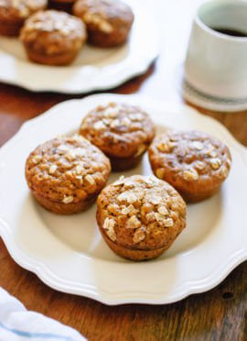
INGREDIENTS
- 1 ¾ cups plain flour
- 1 ½ teaspoons baking powder
- 1 teaspoon ground cinnamon
- ½ teaspoon bicarbonate of soda
- ½ teaspoon salt
- 1 cup grated apple
- 1 cup apple diced into ¼” cubes
- ⅓ cup oil
- ½ cup maple syrup or honey
- 2 eggs, preferably at room temperature
- ½ cup plain Greek yogurt
- 1 teaspoon vanilla extract
- Sugar for dusting on top
METHOD:
- Preheat oven to 200⁰C.
- In a large mixing bowl, combine the flour, baking powder, cinnamon, baking soda and salt. Blend well with a whisk. Add the grated and chopped apple and stir to combine.
- In a medium mixing bowl, combine the oil and maple syrup and beat together with a whisk. Add the eggs and beat well, then add the yogurt and vanilla and mix well.
- Pour the wet ingredients into the dry and mix with a big spoon, just until combined (a few lumps are ok). The batter will be thick, but don’t worry! Divide the batter evenly between the 12 muffin cups.

Hotpot with Dumplings
Ingredients (serves 4) For the Dumplings (makes 8)
Olive oil 100g Self raising flour
1 onion 50g Suet
Button mushrooms 1 egg
2 sticks celery seasoning
1 tin tomatoes
Chicken or quorn pieces
Method
- Heat the oil in a large pan then gently fry the chicken or quorn. Add the onion, mushrooms and celery and cook for 3 minutes.
- Add the tomatoes and seasoning. Cover and simmer.
- Meanwhile, make the dumplings by combining all the ingredients in a bowl and mixing to form a dough. Split the mixture into 8 balls.
- Stir the hotpot then gently place the dumplings on the top, cover and bake for 26 minutes, removing the lid for the last 3 minutes of cooking.

